WEEK 5 Hands on with microservices account and loan outputs

------------------------------------------------------------------------------------------------------------------------

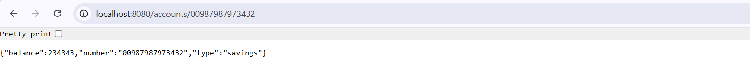

Account microservice successfully executed.

LOAN microservice output:



_________________________________________________________________________________________